General Notes of the 2nd T-LOG/EASTS Logistics IRG Seminar

1. Currency & Exchange
- There is no exchange service to Japanese Yen at Hotel AU Tokoname. Please exchange at Airport (http://www.centrair.jp/en/service/sv-cash/index.html#bnk).
- For the payment at the hotel, credit card and Japanese yen in cash are only available.
- In order to reduce congestion at reception, please pay the seminar fee by Japanese yen as mush as possible, not US $.

2. Access to Tokoname Station by Train
Tokoname Station is only two stops from Central Japan International Airport by train. It is about five minutes’ trip and costs 300 Japanese Yen. All trains except Rapid Limited Express stop at Tokoname St. (Please do not get on Rapid Limited Express). Please also see a map on the next page and below website;
http://www.meitetsu.co.jp/english/transport/line_e04/index.html
*名古屋方面から乗車の際も，快速特急は中部空港直通となり，常滑には停車しませんのでご注意ください．（特急は常滑駅に停まります）

3. Shuttle Bus from the Hotel to JA Building
Shuttle bus will depart at 7:15 (mainly for people to set up the conference rooms) and 8:20 from the hotel. Please wait at the lobby before departure time.

4. Details of Visiting tour on October 25
9:00 Meeting at hotel lobby
9:00-11:00 Walking tour of Tokoname Pottery Path
http://www.tokoname.or.jp/cerapath/path-e.htm
11:00 Return to hotel
11:15 Meeting at hotel lobby again and getting on a bus
11:30-12:30 Lunch
13:30-15:30 TOYOTA Commemorative Museum of Industry and Technology
http://www.tcmit.org/english/index.html
16:00-16:30 Atsuta Shrine
17:30 Return to hotel
*You can drop off the bus at Toyota Museum or Atsuta Shrine if you'd like to.

*If you have any trouble in Japan, please contact me anytime.
Ryuichi SHIBASAKI +81-(0)90-1762-7464

Access Map to Hotel AU Tokoname
http://www.hotel-au.jp/en/access.htm

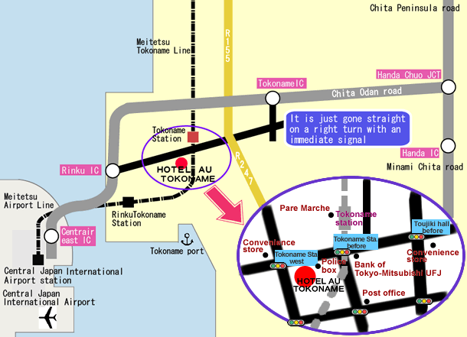
Hotel AU Tokoname 3-174-1 , Shinkai-cho, Tokoname-city Aichi Japan Zip 479-0837
TEL +81-(0)569-36-1600 FAX +81-(0)569-36-1601

